Lessons from the Past: Wildfire
David Price
"More than any other time in history, mankind faces a crossroads. One path leads to despair and utter hopelessness. The other, to total extinction. Let us pray we have the wisdom to choose correctly." - Woody Allen
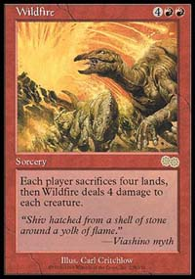
Occasionally, a Magic: The Gathering card comes along that doesn't just find a good home in a traditional Standard deck, get first picked in a draft or get immediately put in the "never going to be used" pile. Sometimes a card can inspire an entirely new type of deck that becomes a dominant force in the tournament scene. Such was the case when Wildfire was introduced in Urza's Saga.
Wildfire first made its presence known in Urza's Block Constructed, at Pro Tour-New York 1999. For the price of two red and four generic mana, Wildfire deals four damage to every creature and forces both players to sacrifice four lands. This can have the effect of both Wrath of God and Armageddon built into one card and in a well-designed deck it can have this effect for only the opponent, leaving your big creatures and artifact mana unmolested. At Pro Tour - New York 1999, Wildfire was used by a significant portion of the competitors and it made a similar presence in the Top 8, playing a prominent role in the championship deck of Casey McCarrel.
Casey McCarrel's Tinker/Wildfire Deck
Pro Tour-New York 1999
Main Deck |  | Sideboard
13 Mountain  6 Island  1 Remote Isle  1 Smoldering Crater  4 Tolarian Academy  1 Crater Hellion  2 Phyrexian Colossus | 4 Grim Monolith  3 Worn Powerstone  4 Voltaic Key  3 Arc Lightning  2 Confiscate  1 Mishra's Helix  1 Phyrexian Processor  2 Ring of Gix  1 Stroke of Genius  3 Temporal Aperture  4 Tinker  4 Wildfire
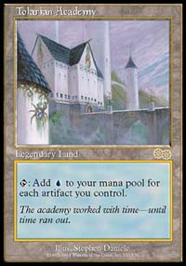
While there were certainly other powerful cards that made McCarrel's deck tick, such as Tolarian Academy, Tinker, and fast artifact mana like Grim Monolith, the raw power of Wildfire provided the deck with a powerful tool in combating creature decks like the speedy monogreen beatdown decks that used Wild Dogs and Pouncing Jaguars for quick beats and Gaea's Cradle for mana acceleration. In addition, Wildfire was often a must counter spell against other control and combo decks, as the loss of lands is a serious detriment to both deck type's strategies.
A better example of the power of Wildfire exists in Kai Budde's World Championship Deck from 1999. This deck was a monored Standard deck that used Wildfire to decimate the opponent's creatures and lands. It lacked both the Tolarian Academy and Tinker that can be found in McCarrel's deck, but it still made use of fast artifact mana to get potentially explosive draws.
Kai Budde's Wildfire Deck
1999 World Championships in Tokyo
Main Deck |  | Sideboard
13 Mountain  4 City of Traitors  3 Ancient Tomb  4 Covetous Dragon  1 Karn, Silver Golem  3 Masticore | 4 Grim Monolith  4 Fire Diamond  2 Worn Powerstone  4 Thran Dynamo  4 Voltaic Key  4 Cursed Scroll  4 Temporal Aperture  2 Mishra's Helix  4 Wildfire
In the Top 8, Kai defeated a number of aggressive weenie decks, that used small green and red creatures in an attempt to deal damage quickly. Wildfire was a key card in the matchups, as it would clear the board of the opponent's smaller creatures while leaving the five toughness Covetous Dragons in play to finish off the opponent.

Key Components

Artifact Mana
Wildfire is an expensive spell, costing . In order for it to be of use against opponents with fast, aggressive decks, it is necessary to have artifact mana to accelerate the deck to that critical six-mana flashpoint. In the event that that fails, Wildfire decks often include ways to slow down a weenie rush, as was the case with Arc Lightning in McCarrel's deck from PT-NY. In addition to its use as simple mana acceleration, artifact mana serves a second purpose, as a permanent source of mana unaffected by Wildfire. Since Wildfire forces both players to sacrifice four lands, artifact mana is unaffected by this devastating effect, making it more likely that the player with artifact mana will have better mana base after a Wildfire resolves.

Surviving the Wildfire
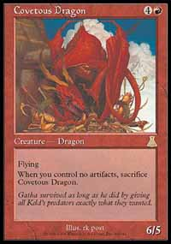
It is critical that the Wildfire player's threats aren't killed by the four damage that the spell deals to all creatures. Otherwise, Wildfire ceases to be an effective threat against control decks, as it doesn't simply work like an Armageddon (a long-feared threat to control players) but as a Wrath of God for the opponent. It is crucial that while the opponent's creatures will likely be destroyed by Wildfire, the Wildfire player's threats should remain in play to finish off the opponent before he or she can recover. Casey McCarrel accomplished this with Crater Hellion and Phyrexian Colossus, who both have greater than four toughness. Kai Budde, too, employed creatures with greater than four toughness. He utilized Covetous Dragon, a 6/5 flier that survived Wildfire and delivered a serious beatdown. He not only used Covetous Dragon but he had a number of Masticores, which survived Wildfire because they could be regenerated. Besides having a greater than four toughness or having the ability to regenerate, there are a number of other creature qualities that would allow it to survive Wildfire. Protection from Red is one of them, as it reduces all damage dealt to the creature from red sources to 0. In addition, some tricky creatures that aren't always creatures or aren't always in play (like Rainbow Efreet) can work around Wildfire as well.

Ways to Make Use of Excessive Mana
Both of these Wildfire decks which we have examined have included an incredibly high amount of mana producers. This is necessary not only because Wildfire is an expensive spell to cast, but because Wildfire destroys the land of both players, making it important the the Wildfire has enough mana to continue playing spells after the Wildfire resolves. Still, when a deck has that much mana, it runs the risk of drawing far more than it needs. To make up for this potential to draw a ton of land and artifact mana, Wildfire decks included ways in which to turn excess mana into more useful resources. For instance, both McCarrel and Budde used Temporal Aperture to turn excess mana into extra cards with Temporal Aperture, Phryexian Processor to creature extra creatures, and Cursed Scroll to deal additional damage. In this way, they were able to dampen the ill effects of getting flooded with mana producers or even use it to their advantage.

So What Now?
With 7th Edition, Wildfire has once again returned to Standard. It has come without Grim Monolith, Tinker, Tolarian Academy, Covetous Dragon, Masticore, Cursed Scroll, and almost every card that can be found in the decks of Casey McCarrel and Kai Budde. So where does that leave us?
By examining the key components of Wildfire decks, we should be able to find some suitable replacements among cards that are Standard legal.
For starters, we are going to need lots of mana for this deck. There aren't many quick and powerful artifact mana producers like Grim Monolith and Thran Dynamo, but there are still some adequate sources of artifact mana. Fire Diamond is still in the basic set and Heart of Ramos is in Masques, both of which produce red mana and are reasonable options for the Standard environment. Aside from these, lands will have to make up the bulk of the deck's mana, with mountains for red mana and Rishadan Ports and Dust Bowls to hurt the opponent's lands either before or after a devastating Wildfire.
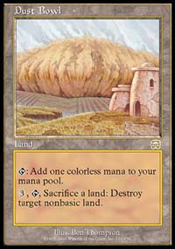
So what can we do for creatures? A number of options come to mind. Chimeric Idol, a three casting cost artifact with can become a 3/3 creature, is perfect for this deck. It is found in a number of tournament winning decks and it can survive a Wildfire with no problem, assuming the controller remembers not to turn it into a creature until after the Wildfire resolves. Scoria Cat, from Prophecy, is another gem. This creature costs and is a 3/3 creature. However, when all of its controller's lands are tapped, it gets +3/+3, effectively making it a 6/6 creature for five mana and provided it with the ability to survive the four damage that Wildfire deals. As if that weren't enough, a fan favorite is back in Seventh Edition to keep Wildfire company: Shivan Dragon. This Dragon is a 5/5 flier for two red and four generic mana, that can kill an opponent in no time flat with its built in firebreathing (its controller can spend red mana to give it +1/+0 for each red mana spent in this way). Not only is it great it combination with Wildfire, but it can simply win games on its own if the opponent is caught unprepared.
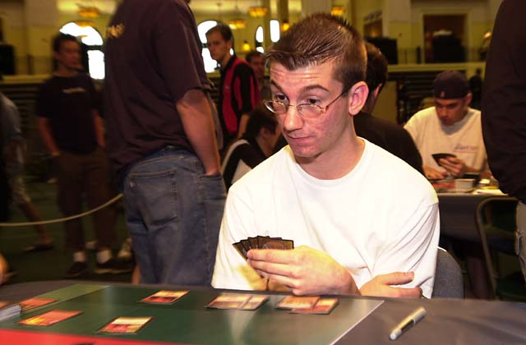
David Bachmann piloted his 'Burning Bridge' Wildfire deck to fourth place at US Nationals.
Without the explosive mana of old school Wildfire decks, it seems unlikely that the deck will have time to use card drawers like Jayemdae Tome. Still, it seems wise to include cards that are useful early on and that can also make use of excess mana. Dust Bowl is one such card, being useful as a source of generic mana in the early game while turning extra lands into land destruction in the late game. Similarly, both Urza's Rage and Ghitu Fire are top notch burn spells, capable of efficiently killing many threatening creatures in the early game and also capable of doing tremendous amounts of damage with enough mana lying around. An Urza's Rage with the kicker can spell doom for many control decks and a Ghitu Fire for ten never hurt either.
Finally, to round things out, it might be a good idea to include Pyroclasm to deal with Fires's quick mana producing Birds of Paradise and Llanowar Elves and Rebel deck's irritating hordes of white weenies, along with Pillage for some much needed artifact destruction or just a little extra land destruction.
The New Wildfire
Main Deck |  | Sideboard
17 Mountains  4 Rishadan Port  2 Dust Bowl  4 Chimeric Idol  4 Scoria Cat  3 Shivan Dragon | 4 Fire Diamond  3 Heart of Ramos  4 Pyroclasm  4 Urza's Rage  3 Ghitu Fire  4 Pillage  4 Wildfire
Put all of the various components together and we end up with quite a good-looking deck. It might take a bit of tuning and playtesting to get it ready for your local Standard environment, but the core concepts and strategies are sound and it contains many powerful creatures and spells. It remains to be seen if Wildfire and its new companions can carry this deck archetype to its previous glory of winning Pro Tours and World Championships, but it certainly deserves a chance to prove itself in the local Standard tournament or in a friendly game down at the comic shop. Even if this isn't the deck for you, it is important to be aware that it could be lurking out there. I also find it useful to remind myself from time to time that studying the successful tournament decks of the past can be an important step in designing successful decks for today.

